**Architecture Design**

Admission system

**Contents**

**List of table** 2

**Revision** 3

**1.** **Introduction** 4

1.1. Purpose of document 4

**2.** **System Context** 5

2.1. System Context 5

**3.** **Decomposition** 6

3.1. Physical View 6

3.2. Dynamic View 7

3.2.1. Level 1 7

3.2.2. Dictionary display system 9

3.2.3. Dictionary display system – web service 11

3.2.4. Dictionary management system 13

3.2.5. Dictionary management system – web service 15

3.3. Static View 16

3.3.1. Top Level 16

3.3.2. Dictionary display system - level 2 17

3.3.3. Dictionary management system - level 2 18

3.3.4. Dictionary display system (android) 20

3.3.5. Dictionary management system (android) 21

**4.** **Mapping** 23

4.1. Physical mapping Dynamic 23

4.1.1. Android devise 23

4.1.2. Dictionary management system 23

4.1.3. Dictuonary management browser 23

4.1.4. Dictionary display system 24

4.1.5. Dictionary display browser 24

4.2. Mapping Dynamic and Static 24

# **List of table**

Table 1: Revision history 3

Table 2: Element catalog System context 5

Table 3: Rational Physical view 6

Table 4: Element catalog Physical view 7

Table 5: Rational Dynamic view Level 1 7

Table 6:Element catalog Dymanic view level 1 8

Table 7: Rational Dynamic view DDS 9

Table 8: Element catalog Dynamic view DDS 10

Table 9: Rational Dynamic view DDS Webservice 11

Table 10: Element catalog Dynamic view DDS Webservice 12

Table 11: Rational Dynamic view DMS 13

Table 12: Element catalog Dynamic view DMS 15

Table 13: Rational Dynamic view DMS Webservice 15

Table 14: Element catalog Dynamic view DMS Webservice 16

Table 15: Rational Static view Top level 16

Table 16: Element catalog Static view Top level 17

Table 17: Rational Static DDS Level 2 17

Table 18: Element catalog DDS Level 2 18

Table 19: Rational Static view DMS Level 2 18

Table 20: Element catalog Static view DMS Level 2 19

Table 21: Rational Static view DDS (android) 20

Table 22: Element catalog Static view DDS (android) 21

Table 23: Rational Static view DMS (android) 21

Table 24: Element catalog Static view DMS (android) 22

Table 25: Mapping Dynamic and Static 25

**List of Figure**

Figure 1: System context 5

Figure 2: Physical view 6

Figure 3: Dynamic view 7

Figure 4: Dictionary display system 9

Figure 5: Dictionary display system Webservice 11

Figure 6: Dictionary management system 13

Figure 7: Dictionary management system Webservice 15

Figure 8: Static view Top level 16

Figure 9: Dictionary display management Level 2 17

Figure 10: Dictionary management system Level 2 18

Figure 11: Dictionary display system (android) 20

Figure 12: Dictionary management system (android) 21

Figure 13: Mapping android devise 23

Figure 14: Mapping DMS 23

Figure 15: Mapping DMS browser 23

Figure 16: Mapping DDS 24

Figure 17: Mapping DDS browser 24

**Revision**

|  |  |  |  |  |
| --- | --- | --- | --- | --- |
| **No** | **Version** | **Update date** | **Author** | **Content** |
| 1 | 1.0 | 12/27/2013 | Ta Ngoc Thiên Phu | Create document |
| 2 | 1.1 | 0116/2014 | Ta Ngoc Thiên Phu | Update Dynamic View |
| 3 | 1.2 | 01/20/2014 | Ta Ngoc Thiên Phu | Update System Context, Static View, Physical View and Edit Dynamic |
| 4 | 1.3 | 01/24/2014 | Ta Ngoc Thiên Phu | Edit Static View, Physical View, Dynamic View, Mapping |
| 5 | 1.4 | 05/23/2014 | Ta Ngoc Thiên Phu | Edit content of catalog elements |
| 6 | 1.5 | 05/28/2014 | Ta Ngoc Thiên Phu | Update document: update static view, Mapping |

Table 1: Revision history

# **Introduction**

## Purpose of document

Document descripts architecture of Dictionary display system and Dictionary management system (website and android) in Admission System project. Dictionary display system is a website/android app that users can research information about Van Lang University and Dictionary management system is a website/android app that system managers of Van Lang University manage question of users.

# **System Context**

## System Context



Figure 1: System context

|  |  |
| --- | --- |
| **Element** | **Description** |
| Dictionary display system | Dictionary display system is a web application on server, users can research information about Van Lang university and send questions. Dictionary display system was configure web service to get request from Display system (android) |
| Dictionary management system | Dictionary management system is a web application on server, system manager manage all question from users. Dictionary management system was configure web service to get request from Management system (android) |
| Display system (android) | Display system (android) is an android application that is installed on android devices. Users can research information about Van Lang university and send questions |
| Management system (android) | Management system (android) is an android application that is installed on android devices. System manager manage all question from users |
| Users Management | This is module that manage all information of system users |

Table 2: Element catalog System context

# **Decomposition**

## Physical View



Figure 2: Physical view

|  |  |
| --- | --- |
| **Associated Drawings:** Figure 2 | **Perspective:** Dynamic |
| This is overvier architecture design of hardware system, this architect use Deployment style to show the hardware system of Admission system. It can solve quality attributes:  **Security**  - Use a firewall to prevent / reduce the unauthorized access from network to ensure data safety.  - The hiring of outside web server to separate display system and management system, ensures the data safety.  **Performance**  the server's response is stable when 1000 users access to system | |

Table 3: Rational Physical view

|  |  |
| --- | --- |
| **Element** | **Description** |
| Client Browser | Client Browser is used by users who will interacte to Dictionary display system by internet. This system support:   * Google chrome version 23-25 * Firefox version 14-16 * Internet explorer version 9-11 |
| Android device | Electronic devices (tablet, smartphone) that use android platform. It is used by users or system manager. They will access to dictionary display system or dictionary management system by web service. |
| Web server 1 | Web service is used to receive and processing all request from client. It run on Windows server 2008 and integrate Email server  **Note**: Email servie is used to send mail to clients |
| Firewall | Firewall is used to prevent and reduces access that is not allow or attacks from inside and outside |
| Database intranet | .Database is used by dictionart management system and develop on MySQL platform |
| Web server 2 | Web server 2 that is used outside local network, it will receive and processing all request from client. It run on Windows server 2008. |
| Database internet | Database is accessed by Web service 2 (Dictionary display system) and develop on MYSQL platform |
| Internet | Vùng mạng trung gian để client kết nối đến vùng mạng chính của mình. |
| Web service | Web service is configurate on Web server 1 and Web server. They are used to support to tools can send and receive request by HTML and support to android devise get data from dictionary display system and dictionary management system |
| Service external | Service external is outsourced service to contrain Web server 2 and Database internet |

Table 4: Element catalog Physical view

## Dynamic View

### Level 1



Figure 3: Dynamic view

|  |  |
| --- | --- |
| **Associated Drawings:** Hình 1 | **Perspective:** Dynamic |
| Architecture design show overview architecture of Question and Anwser System include web and android  Web components use file config, system can operate standalone | |

Table 5: Rational Dynamic view Level 1

|  |  |
| --- | --- |
| **Element** | **Description** |
|  | Dictionary display system is a web application on server, users can research information about Van Lang university and send questions. Dictionary display system was configure web service to get request from Display system (android) |
|  | Dictionary management system is a web application on server, system manager manage all question from users. Dictionary management system was configure web service to get request from Management system (android) |
|  | Management system (android) is an android application that is installed on android devices. System manager manage all question from users |
|  | Display system (android) is an android application that is installed on android devices. Users can research information about Van Lang university and send questions |
|  | Server that use receive and send mail |
|  | File config is created to support system that will operation focus and operaton independenct |
|  | This local database is used in Van Lang University. It contain information of system users and information about dictionary |
|  | This database contain information of dictionary |
|  | Java call is communication protocol between components in java |
|  | Simple Mail Transfer Protocol (SMTP) is an Internet standard for electronic mail (e-mail) transmission. |
|  | JDBC is a Java-based data access technology (Java Standard Edition platform) from Oracle Corporation |
|  | File I/O is file access protocol |
|  | FTP is protocol that is use to transfer file |
|  | Web service is a method of communications between two electronic devices over a network |

Table 6: Element catalog Dymanic view level 1

### Dictionary display system



Figure 4: Dictionary display system

|  |  |
| --- | --- |
| **Associated Drawings:** Figure 4 | **Perspective:** Dynamic |
| This is architecture design level 2 of Dictionary display system. It show detail of Dictionary display system include processes of Dictionary display system, file, interact between processes and other system  This architecture design use lucense search, it can meet QA:   * Search question in dictionary, the returned results is fast * The returned results have high accuracy (accuracy about 80%) | |

Table 7: Rational Dynamic view DDS

|  |  |
| --- | --- |
| **Element** | **Description** |
|  | Search is process that will search data from index file and return result to Display |
|  | Create question is process that create new question and send it to Dictionary management system |
|  | Display is process that have functions:   * Receive request from browser and send it to Search * Receive search result and display result * Display create question interface |
|  | This is process that receive all request that is sent by web service protocol  *this process is decomposed in next architecture design* |
|  | Update dictionary is process, it’ll receive update dictionary from Dictionary management system and it’ll update database Internet |
|  | Display system (android) is an android application that is installed on android devices. Users can research information about Van Lang university and send questions |
|  | Dictionary management system is a web application on server, system manager manage all question from users. Dictionary management system was configure web service to get request from Management system (android) |
|  | This database contain information of dictionary |
|  | This is file that is created by Dictionary management system, It’s used to search data |
|  | Java call is communication protocol between components in java |
|  | JDBC is a Java-based data access technology (Java Standard Edition platform) from Oracle Corporation |
|  | File I/O is file access protocol |
|  | Web service is a method of communications between two electronic devices over a network |

Table 8: Element catalog Dynamic view DDS

### Dictionary display system – web service



Figure 5: Dictionary display system Webservice

|  |  |
| --- | --- |
| **Associated Drawings:** Hình 3 | **Perspective:** Dynamic |
| This is architecture design level 3 of Dictionary display system, it show detail of Web service process. Each process of Web service process will receive request and processing request that is sent from other tools by web service protocol. | |

Table 9: Rational Dynamic view DDS Webservice

|  |  |
| --- | --- |
| **Element** | **Description** |
|  | Android – Search is a process: Its role is search data from index file and return result to Android- Dictionary display system |
|  | Android – Display is process that receive search request from Android – Dictionary display system and send request to Android – Search process and receive search result |
|  | Android – Create question is a process. Its role is receive question from android and send question to Dictionary management system |
|  | Dictionary management system is a web application on server, system manager manage all question from users. Dictionary management system was configure web service to get request from Management system (android) |
|  | This database contain information of dictionary |
|  | Display system (android) is an android application that is installed on android devices. Users can research information about Van Lang university and send questions |
|  | Web service is a method of communications between two electronic devices over a network |
|  | JDBC is a Java-based data access technology (Java Standard Edition platform) from Oracle Corporation |
|  | File I/O is file access protocol |
|  | Java call is communication protocol between components in java |

Table 10: Element catalog Dynamic view DDS Webservice

### Dictionary management system



Figure 6: Dictionary management system

|  |  |
| --- | --- |
| **Associated Drawings:** | **Perspective:** Dynamic |
| This architecture design show business process, each process is operate independently that a reason this tool can increate Performace QA  This architecture design use lucense search, it can meet QA:   * Search question in dictionary, the returned results is fast * the returned results have high accuracy | |

Table 11: Rational Dynamic view DMS

|  |  |
| --- | --- |
| **Element** | **Description** |
|  | Search is a process, its role is search data and return result |
|  | Display is process that receive all requests from users and navigate other processes |
|  | Insert question into dict is process that allow system manager can Insert question into dict to dictionary |
|  | Send Mail is process that allow system manager can reply questions which is sent from users |
|  | Drop-dict is a process that allow system manager can remove any question to dictionary |
|  | Delete question is process that allow system manager can delete questions |
|  | Create index is process that allow system manager can create index file and send this file to Dictionary display system by FTP |
|  | Save Question is a process, It’ll receive question that is sent by users and saved it to database |
|  | Web service is process, It handles all request that have relative android |
|  | Dictionary display system is a web application on server, users can research information about Van Lang university and send questions. Dictionary display system was configure web service to get request from Display system (android) |
|  | This local database is used in Van Lang University. It contain information of system users and information about dictionary |
|  | This is file that is created by Dictionary management system, It’s used to search data |
|  | This is service that receive and send mail |
|  | Management system (android) is an android application that is installed on android devices. System manager manage all question from users |
|  | Web service is a method of communications between two electronic devices over a network |
|  | FTP is an acronym for File Transfer Protocol. As the name suggests, FTP is used to transfer files between computers on a network |
|  | Simple Mail Transfer Protocol (SMTP) is an Internet standard for electronic mail (e-mail) transmission. |
|  | JDBC is a Java-based data access technology (Java Standard Edition platform) from Oracle Corporation |
|  | File I/O is file access protocol |

Table 12: Element catalog Dynamic view DMS

### Dictionary management system – web service



Figure 7: Dictionary management system Webservice

|  |  |
| --- | --- |
| **Associated Drawings:** | **Perspective:** Dynamic |
| This is architecture design of web service process. It show all items of web service process | |

Table 13: Rational Dynamic view DMS Webservice

|  |  |
| --- | --- |
| **Element** | **Description** |
|  | Android – Send Mail is process that is used to Send Mail that was sent to Management system (android) |
|  | Android – Insert question into dict is a process, Its role:  1/ Insert question into dict to Dictionary when Management system (android) sent requests.  2/ Update database Intranet when Management system (android) sent requests. |
|  | Android – Drop is a process. Its role:  1/ Drop-dict that is existing in Dictionary when Management system (android) sent requests.  2/ Update database Intranet when Management system (android) sent requests. |
|  | Android – Search is process that will receives keywords from Management system (android), search data and return result |
|  | Android – Display is a process that receives all requests from Management system (android)and navigate other processes |
|  | Dictionary display system is a web application on server, users can research information about Van Lang university and send questions. Dictionary display system was configure web service to get request from Display system (android) |
|  | Management system (android) is an android application that is installed on android devices. System manager manage all question from users |
|  | This local database is used in Van Lang University. It contain information of system users and information about dictionary |
|  | Web service is a method of communications between two electronic devices over a network |
|  | FTP is an acronym for File Transfer Protocol. As the name suggests, FTP is used to transfer files between computers on a network |
|  | Simple Mail Transfer Protocol (SMTP) is an Internet standard for electronic mail (e-mail) transmission. |
|  | JDBC is a Java-based data access technology (Java Standard Edition platform) from Oracle Corporation |
|  | File I/O is file access protocol |

Table 14: Element catalog Dynamic view DMS Webservice

## Static View

### Top Level



Figure 8: Static view Top level

|  |  |
| --- | --- |
| **Associated Drawings:** | **Perspective:** Static |
| This is general architecture design about Static View. It show general all component of Question & Answer System and Interaction between Layers | |

Table 15: Rational Static view Top level

|  |  |
| --- | --- |
| **Element** | **Description** |
| **Controller** | * Responsible for processing user requests and building appropriate model and passes it to the view for rendering. |
| **Presentation Layer** | Responsible for rendering the model data and in general it generates HTML output that the client's browser can interpret. |
| **Service Layer** | Responsible for processing related to business logic. |
| **Data Access Layer** | Responsible for processing related to connect database. |
| **Domain Object** | It describes the various entities, their attributes. |
| **Util** | Have some class support for business problems |
| **Validator** | Responsible for check value input before processing operations. |
| **Bean** | It is one part of model supports to controller building appropriate model. |
| **WSA** | Its role is processing all requests that relate android by Webservice |

Table 16: Element catalog Static view Top level

### Dictionary display system - level 2

 Figure 9: Dictionary display management Level 2

|  |  |
| --- | --- |
| **Associated Drawings:** | **Perspective:** Static |
| This architecture use to patterms: decompose style, use style and layer style show independent components and show relationship between components | |

Table 17: Rational Static DDS Level 2

|  |  |
| --- | --- |
| **Element** | **Description** |
| **Web Interface** | Web Interface contrain all component that relate to user interface on Dictionary display system |
| **Presentation Layer** | Responsible for rendering the model data and in general it generates HTML output that the client's browser can interpret. |
| **Display Dictionary** | Display Dictionary contain all interface relate to dictionary management |
| **Dictionary Controller** | Responsible for processing user requests and building appropriate model and passes it to the view for rendering. |
| **Webservice Controller** | Its role is processing all requests that is sent from Dictionary display system by Webservice |
| **Send Question** | Send question is package that contrain interfaces about send question |
| **Service Interface** | Service Interface is a component of Service Layer, it contrain all interface relate processing service of Dictionary display system |
| **Display Dictionary**  **service** | Display Dictionary service contain all business logic processing about search data, show question list |
| **Send Question**  **service** | Send Question service contain all business logic processing about send question |
| **Service Implementations** | Service Implementations is a component of Service Layer which contain all implement component about server of Dictionary display system |
| **DAL Interface** | DAL Interface is a component of Data Access Layer, it contrain all component relate to Interface about service of Dictionary display system |
| **Display Dictionary**  **DAL** | Display Dictionary DAL contain all query processing about show question list |
| **Send Question**  **DAL** | Display Dictionary DAL contain all query processing about send question |
| **DAL Implementations** | DAL Implementations is a component of Data Access Layer, it contain all component relate to Implement of Dictionary display system |
| **Domain Object** | It describes the various entities, their attributes. |
| **WSA** | Its role is processing all requests that relate android by Webservice |
| **Util** | Have some class support for business problems |
| **Validator** | Responsible for check value input before processing operations. |
| **Bean** | It is one part of model supports to controller building appropriate model. |

Table 18: Element catalog DDS Level 2

### Dictionary management system - level 2



Figure 10: Dictionary management system Level 2

|  |  |
| --- | --- |
| **Associated Drawings:** | **Perspective:** Static |
| This architecture use to patterms: decompose style, use style and layer style show independent of components and show relationship between components | |

Table 19: Rational Static view DMS Level 2

|  |  |
| --- | --- |
| **Element** | **Description** |
| **Question Management Controler** | Question Management Controller is component that use control processor of Dictionary management system |
| **Presentation Layer** | Responsible for rendering the model data and in general it generates HTML output that the client's browser can interpret. |
| **Web Interface** | Web Interface contrain all component that relate to user interface on Dictionary management system |
| **Question Management Interface** | Question Management Interface contrain interface of list-question, list- repied, list-saved, list -delete. |
| **Dictionary Interface** | Dictionary Interface contrain interface that relate to dictionary: list-available, list-recent, list-remove, list-delete. |
| **System Management Interface** | System management interface contrain interface that relate to system management and user management. |
| **Service Layer** | Responsible for processing related to business logic. |
| **Question Management service** | Question management service contrain class that’s processing business logic of request relate to question management |
| **Dictionary service** | Dictionary service contrain class that’s processing business logic of request relate to Dictionary |
| **Users Management service** | **Users Management service** contrain class that’s processing business logic of request relate to system management and user management |
| **Service Interface** | Service Interface is a component of Service Layer, it contrain all interface relate processing service of Dictionary management system |
| **Service Implement** | Service Implement is a component of Service Layer that contrain business logic processing of Dictionary management system |
| **Data Access Layer** | Data Access Layer contrain all query database |
| **Question Management DAL** | Question Management DALcontain all query that relate question management |
| **Dictionary DAL** | Dictionary DAL contrain all query that relate dictionary management |
| **System Management DAL** | System management DAL contain all query that relate system meanagement |
| **Data Access Interface** | Data Access Interface is a component of DAL. It contrain all interface about servive of Dictionary management system |
| **Data Access Implement** | Data Access Implement is a component of DAL. It contrain all business logic processing about servive of Dictionary management system |
| **Domain Object** | It describes the various entities, their attributes. |

Table 20: Element catalog Static view DMS Level 2

### Dictionary display system (android)



Figure 11: Dictionary display system (android)

|  |  |
| --- | --- |
| **Associated Drawings:** | **Perspective:** Static |
| This is architecture design of Display system (android). It use decomposition style, layer style and use style to show relationship between components on android | |

Table 21: Rational Static view DDS (android)

|  |  |
| --- | --- |
| **Element** | **Description** |
| **GUI** | GUI is a layer that contain all processing relate to interface |
| **Business Logic** | Business Logic is a layer that contain all processing relate to business logic |
| **Web service Access** | WSA is a layer that contain all processing relate to database connection |
| **Dictionary Display GUI** | Dictionary Display GUI is a component of GUI layer, Its role is show dictionary list for Dictionary Displayy System |
| **Send Question GUI** | Send Question GUI is a component of GUI. It’ll show Send Question interface |
| **Dictionary Display service** | Dictionary Display service is a component of Business Logic Layer, it contain all processing relate to business logic of show list |
| **Send Question service** | Send Question service is a component of Business Logic Layer, it contain all processing relate to business logic of create and send question |
| **Dictionary Display WSA** | Dictionary Display DAO is a component of WSA layer. It contain all processing relate to web service about show list |
| **Send Question WSA** | Send Question DAO is a component of WSA layer. It contain all processing relate to web service about create and send question |

Table 22: Element catalog Static view DDS (android)

### Dictionary management system (android)



Figure 12: Dictionary management system (android)

|  |  |
| --- | --- |
| **Associated Drawings:** | **Perspective:** Static |
| This is architecture design of Mângement system (android). It use decomposition style, layer style and use style to show relationship between components on android | |

Table 23: Rational Static view DMS (android)

|  |  |
| --- | --- |
| **Element** | **Description** |
| **GUI** | GUI is a layer that contain all processing relate to interface |
| **Question management GUI** | Question management GUI is component of GUI layer. It contain all processing relate to interface about question management |
| **Dictionary GUI** | Dictionary GUI is component of GUI layer. It contain all processing relate to interface about dictionary management |
| **System management GUI** | System management GUI is component of GUI layer. It contain all processing relate to interface about system management |
| **Business Logic** | Business Logic is a layer that contain all processing relate to business logic |
| **Question management service** | Question management BL is component of BL layer. It contain all processing relate to business logic about question management |
| **Dictionary service** | Dictionary BL is component of BL layer. It contain all processing relate to business logic about dictionary management |
| **Users Management service** | System management BL is component of BL layer. It contain all processing relate to business logic about system management |
| **Web service access** | WSA is a layer that contain all processing relate to database connection |
| **Question management WSA** | Question management WSA is component of WSA layer. It contain all processing relate to Web service about question management |
| **Dictionary WSA** | Dictionary WSA is component of WSA layer. It contain all processing relate to Web service about dictionary management |
| **System management WSA** | System management WSA is component of WSA layer. It contain all processing relate to Web service about system management |

Table 24: Element catalog Static view DMS (android)

# **Mapping**

## Physical mapping Dynamic

### Android devise

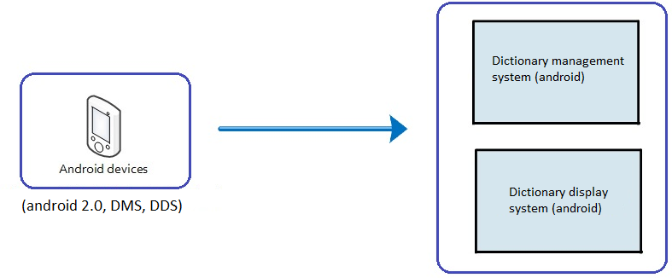

Figure 13: Mapping android devise

### Dictionary management system

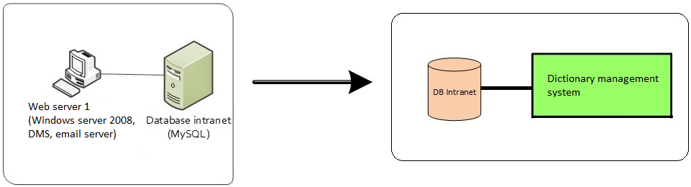

Figure 14: Mapping DMS

### Dictuonary management browser

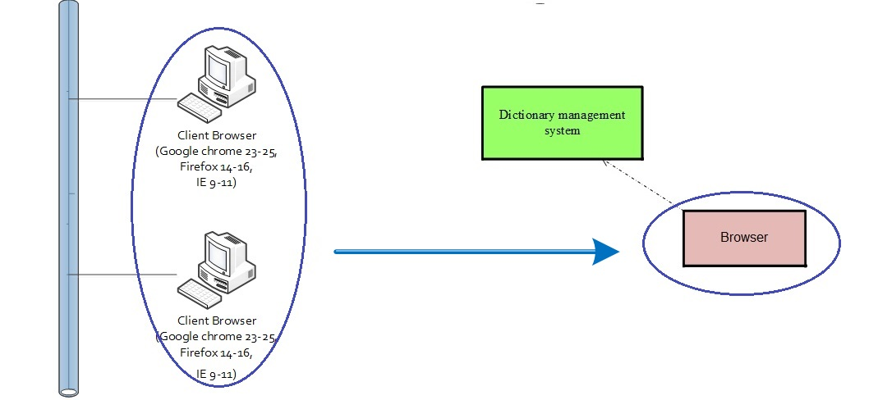

Figure 15: Mapping DMS browser

### Dictionary display system

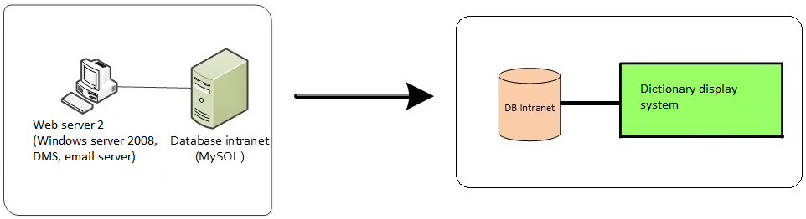

Figure 16: Mapping DDS

### Dictionary display browser

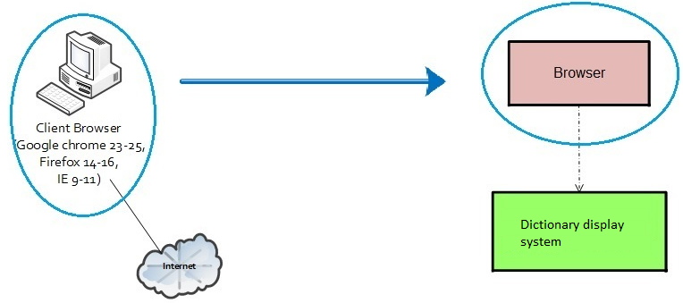

Figure 17: Mapping DDS browser

## Mapping Dynamic and Static

|  |  |
| --- | --- |
| **Dynamic** | **Static** |
| Display (Dictionary Display System) | Display Dictionary - Interface  Send Dictionary – Interface  Dictionary Controller |
| Search (Dictionary Display System) | Display Dictionary - Service  Display Dictionary – Data Access  Dictionary Controller |
| Create question | Send Dictionary – Service  Send Dictionary – Data Access  Dictionary Controller |
| Update Question | Display Dictionary - Service  Display Dictionary – Data Access  Dictionary Controller |
| Web service | Webservice Controller |
| Delete question | Question management – Service  Question management – Data Access  Dictionary - Service  Dictionary – Data Access  Question Management Controller  Dictionary Controller |
| Search (Dictionary Management System) | Question management – Service  Question management – Data Access  Dictionary - Service  Dictionary – Data Access  Question Management Controller  Dictionary Controller |
| Display (Dictionary Management System) | Question management – Interface  Dictionary – Interface  Question Management Controller  Dictionary Controller |
| Create Index | System management – Service  System management – Data Access  System management Controller |
| Insert question | Dictionary - Service  Dictionary – Data Access  Dictionary Controller |
| Drop question | Dictionary - Service  Dictionary – Data Access  Dictionary Controller |
| Send Mail | Question management – Service  Question management – Data Access  Question Management Controller |
| Save question | Question management – Service  Question management – Data Access  Question Management Controller |
| Web service | Webservice Controller |

Table 25: Mapping Dynamic and Static